**Name: Nafinur Leo**

**Id: 20-42195-1**

**Course Name: Data Communication**

**Section: D**

**Lab Exam: 01**

**Semester: 2021-2022 Fall**

**Submission Date: 18-10-2021**

ID = AB-CDEFG-H

Here, my id is: 20-42195-1

A = 2, B = 0, C = 4, D = 2, E = 1, F = 9, G = 5, H = 1

a1 = G+3 = 5 + 3 = 8

a2 = G+5 = 5 + 5 = 10

a3 = G+4 = 5 + 4 = 9

f1 = G+1 = 5 + 1 = 6

f2 = G+9 = 5 + 9 = 14

f3 = G+7 = 5 + 7 = 12

L = 10

a)A composite signal in time domain:

Code:

clc

close all

A = 2;

B = 0;

C = 4;

D = 2;

E = 1;

F = 9;

G = 5;

H = 1;

a1 = G+3;

a2 = G+5;

a3 = G+4;

f1 = G+1;

f2 = G+9;

f3 = G+7;

L = 10;

fs = 30000;

t = 0:1/fs:0.001;

sig_ct = a1*sin(2*pi*f1*t) + a2*cos(2*pi*f2*t + pi/6) + a3*cos(2*pi*f3*t);

Nsamples=length(sig_ct);

quantised_out=zeros(1,Nsamples);

del=(max(sig_ct)-min(sig_ct))/(L);

sig_ct2=min(sig_ct)+(round((sig_ct-min(sig_ct))/del)).*del;

figure;

plot(t,sig_ct,'*' );

hold on;

plot(t,sig_ct2,'x');

hold off;

title('A Composite Signal In Time Domain')

xlabel('time')

ylabel('amplitude')

legend ('Original Signal','Quantized Signal');

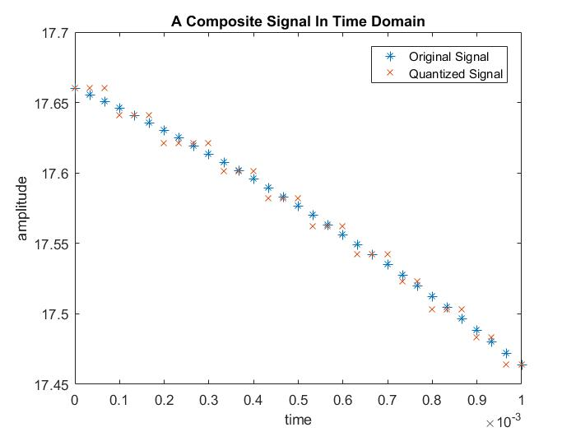

b)Calculation and comparison of SNR, capacity of the channel in bps:

Code:

clc

close all

A = 2;

B = 0;

C = 4;

D = 2;

E = 1;

F = 9;

G = 5;

H = 1;

a1 = G+3;

a2 = G+5;

a3 = G+4;

f1 = G+1;

f2 = G+9;

f3 = G+7;

L = 10;

fs = 30000;

t = 0:1/fs:0.001;

sig_ct = a1*sin(2*pi*f1*t) + a2*cos(2*pi*f2*t + pi/6) + a3*cos(2*pi*f3*t);

noise=(F+2)*randn(size(t));

SNR = snr(sig_ct,noise)

ps = a1^2/2 + a2^2/2 + a3^2/2;

pn=(F+2)^2;

SNR_theory = 10*log10(ps/pn)

comp = [SNR SNR_theory]

bandwidth=obw(sig_ct,fs);

Capcity_of_channel_SNR = bandwidth*log2(1+SNR)

Capcity_of_channel_SNR_theory = bandwidth*log2(1+SNR_theory)

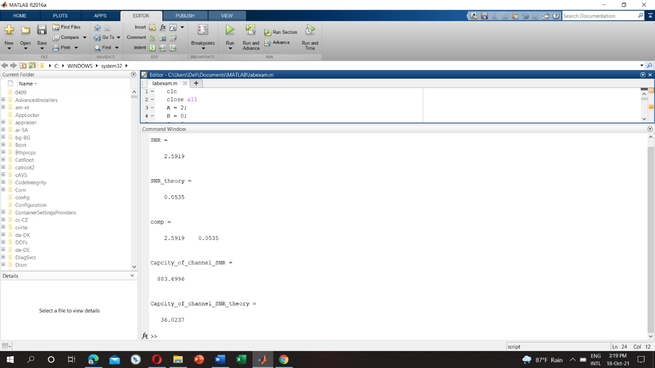

The SNR value doesn’t match with each other. MATLAB has built in function. It’s calculated automatically. But in theoretically, it works manually. So, there is a difference between those values.